Title
Forename Surname ^{1,*}, Forename Surname ² and Forename Surname ²
¹ IAMU member university, Country
² Second affiliation, Country
* Corresponding author: author@university.xx; Tel.: +00-00-000-0000.

Keywords: first keyword; second keyword; third keyword (three to five pertinent keywords should be listed)

These instructions provide authors with guidelines for typing camera-ready abstracts for the 23rd International Association of Maritime Universities Conference Book. This electronic document is a “live” template and is used to format the abstract and style the text. Abstracts are limited to one page of text and a second, optional page with up to four figures/tables. The abstract should clearly explain the content and relevance of the work. Authors must keep their camera-ready abstracts in the A4 paper size, Times New Roman font is strictly required, all margins, line spaces and text fonts are prescribed, and page numbers should not be added. Reference list style has to be the same as for the WMU Journal of Maritime Affairs (JoMA 2020). References have to be cited in the text by name and year in parentheses. Authors should submit their abstracts electronically to iamuc23@samk.fi. The abstract submission deadline is 1st of March 2023.

The theme of the IAMUC is Quality of the Education of Global Maritime Professionals.
When submitting your abstract, please indicate one of the following theme categories in which the abstract will be registered and reviewed:
Themes categories:
- Breakthrough Technologies for Seafaring and MET
- Managing Maritime Safety and Security
- Environmental Sustainability in Seafaring
- Education of Global Maritime Professionals

Submission of an abstract will be taken to imply that it represents an original work and that it has not been previously published or considered elsewhere for publication. Please be aware that authors are responsible for the English language quality of the text. Notification of acceptance will be given by 15th of March 2023.
The accepted abstract will be assigned by the International Program Committee for oral or poster presentation, not only on the basis of the author's preference indicated in the email submission, but also on the quality of the abstract and number of the oral presentations allocated.
All presented abstracts will be published in the Conference Book with assigned ISSN identifier. The authors will be invited to submit a full paper version for inclusion in the IAMUC Proceedings. Instruction to prepare the full paper will be emailed together with the notification of the abstract. The full paper will be requested by 15th April 2023. The Proceedings papers authors will have opportunity to submit an extended version of the paper to IAMUC Special Issue of the IAMU Section of WMU Journal of Maritime Affairs.

References
International Hydrographic Organization (2017) Information on IHO standards related to ENC and ECDIS. Version 1.1. IHO, Monaco
WMU Journal of Maritime Affairs (JoMA) (2020) WMU Journal of Maritime Affairs, Submission guidelines. Springer Nature. https://www.springer.com/journal/13437/submission-guidelines. Accessed 3 March 2020
Svilicic B, Rudan I, Jugović A, Zec D (2019) Cyber security testing of shipboard chart radar. Proceedings of the International Association of Maritime Universities Conference, Tokyo, Japan, 129-134
Walling SA, Hill JC (2014) Elementary Marine Navigation. Cambridge University Press, Cambridge

Illustrations should contain only English labels and be prepared in the final published size, not oversized or undersized. Each illustration has to have a caption (Figure 1).
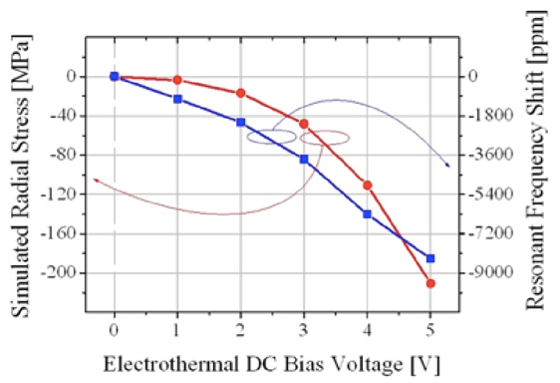

Figure 1. An example of a figure.

Tables have to be submitted as editable text and not as images. Each table has to have a caption (Table 1).

Table 1. An example of a table.
An example of a column heading | Column A | Column B
First entry | 1 | 2
Second entry | 3 | 4
Third entry | 5 | 6

Acknowledgements
If a funding has been provided for the research, please include brief information on the program or type of grants and awards.

